RESOLUTION NO.__________

RE: CERTIFICATE OF APPROPRIATENESS UNDER THE
PROVISIONS OF THE ACT OF THE PENNSYLVANIA
LEGISLATURE 1961, JUNE 13, P.L. 282 (53
SECTION 8004) AND BETHLEHEM ORDINANCE NO.
3952 AS AMENDED.

WHEREAS, it is proposed to install a blade sign and vinyl window lettering at 459 Main St.

NOW, THEREFORE, BE IT RESOLVED by the Council of the City of Bethlehem that a Certificate of Appropriateness is hereby granted for the proposal.

Sponsored by: (s)

(s)

ADOPTED BY COUNCIL THIS DAY OF

(s)
President of Council

ATTEST:

(s)
City Clerk

HISTORICAL & ARCHITECTURAL REVIEW BOARD

APPLICATION #1: The applicant proposes to install a blade sign and vinyl window
lettering at 459 Main St.

OWNER: Brad Mulkern
457 Main St., Suite 700, Bethlehem, PA 18017
__________________________________________________________________

The Board upon motion by Beth Starbuck and seconded by Marsha Fritz adopted the proposal that City Council issue a Certificate of Appropriateness for the following:

- Vinyl lettering on the transom to be resized to align with the width of the pair of doors below.

- The colors to be off-white to match the window frame and the red to be a Burgundy color.

3. The motion was unanimously approved.

__________________________________________________________________________

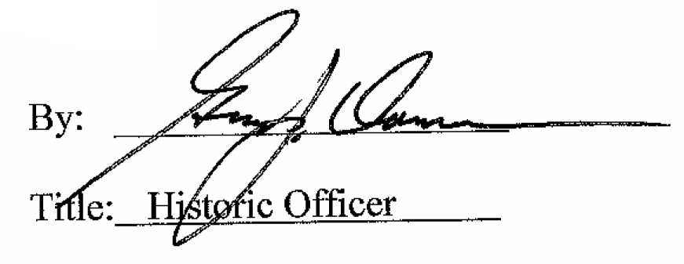

Date of Meeting: November 5, 2014

